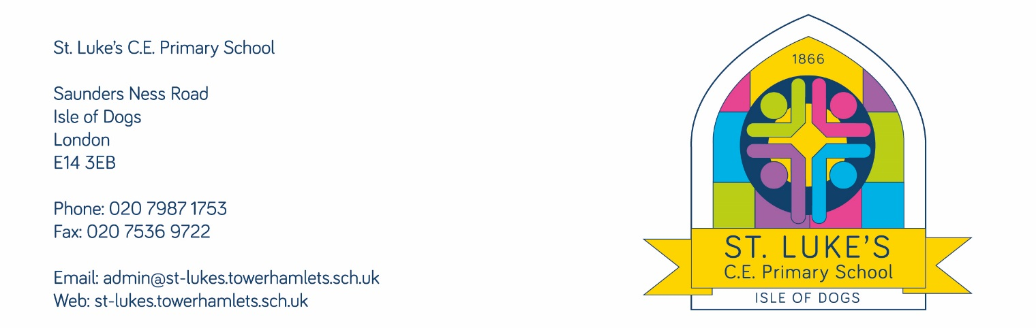
Dear Parents & Carers,

The online world is posing an ever-increasing risk to children, and it is important that schools, parents and carers work together to take an active role in teaching children about online dangers. Learning how to act safely when using the internet is an incredibly important part of safeguarding our children.

We are therefore delighted to announce that St Luke's Church of England Primary School have shown our commitment to protecting our pupils online by working with the organisation National Online Safety - providing resources for all parents and carers. We have signed up to a school community package so that all staff, governors and parents/carers can access the online resources, which includes a variety of webinars, videos and reading resources available.

The resources include a Parents & Carers course that can be taken at your own convenience, which covers:

- Online Relationships  - Fake Profiles & Social Bots  - Online Bullying  - Online Grooming  - Child Sexual Exploitation  - Sexual Harassment & Violence  - Sexting  - Live Streaming  - Online Identity  - Screen Addiction  - Online Challenges  - Overspending | - Online Gambling  - Radicalisation, Terrorism & Extremism  - Age Inappropriate Content  - Copyright & Ownership  - Hacking  - Fake News  - Online Fraud  - Online Reputation  - Personal Data  - Pornography  - Targeted Adverts & Pop-Ups  - The Dark Web
To create your account, please follow http://nationalonlinesafety.com/enrol/st-luke-s-church-of-england-primary-school-2 , complete your details and select “I am a: Parent/Carer” as your account type.

Once you have registered, you will be able to access the “Online Safety for Parents and Carers” course and National Online Safety’s Resources, which includes a wide range of online platform guides on the latest social media channels and games.

National Online Safety release a brand-new guide every week, which aims to cover all major social media platforms, apps and issues that children encounter online. This aims to help empower parents with the knowledge to protect their children from the dangers of the internet.

Please also see attached the User Guide for Parents and Carers. If you have any questions, or trouble accessing the course please contact support@nationalonlinesafety.com or homelearning@st-lukes.towerhamlets.sch.uk

Kind Regards,

Miss Nagahawatte

