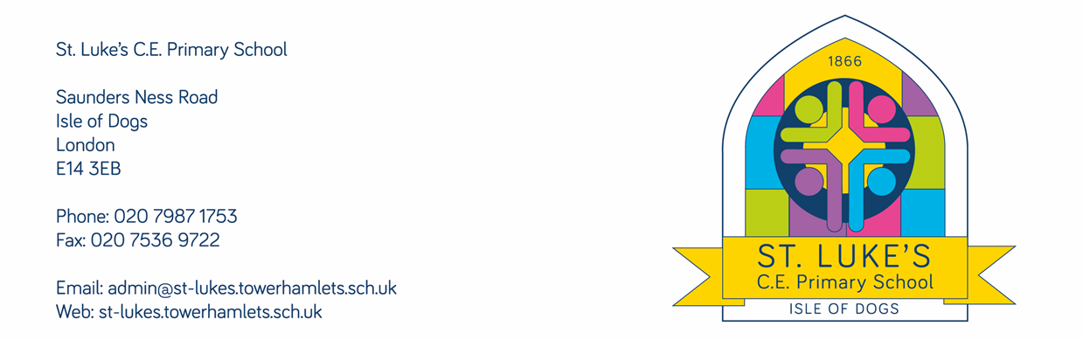

08 December 2021

Dear parents and carers,
You will no doubt be aware of the rising cases of Covid both nationally and in school. At present, government guidance remains that all children should continue to come to school as normal, and only those who have symptoms or test positive should isolate. We will continue to inform Public Health of the Covid cases we have in school, and they will advise us if they feel that we should take any further action. To date, they have not advised us to make any changes.
We know how much parents and families are looking forward to seeing the children perform in the nativities in person, and we would like to keep this arrangement in place, whilst considering how to reduce the risk of transmission as much as possible. I am sure that you would agree that avoiding a risk of an outbreak in the week before Christmas should be a top safety priority for us all.
We have therefore made some adjustments to the arrangements for the nativity performances for next week, to reduce the number of people in the hall at any one time.
We have decided to put in an additional performance for each nativity (from years 1 to 6) to enable the audience numbers to be reduced to parents of just two classes. The limit of two audience members per child remains in place, but please note that this limit includes any children you bring with you. We will also be introducing a ticketing system to ensure that access is fair to everyone. On the day before your child’s performance, your child will be given two raffle tickets with their name and class on. You will need these to be able to enter the hall. Please hand them to a member of staff as you come into the building. Please note that all adults in the audience will be required to wear a mask. If you are able to, we would also welcome people taking Lateral Flow Tests before attending as an extra precaution. Please also note that we do reserve the right to make additional changes if the situation, either nationally or in school, changes further, although we will do our very best to keep to the arrangements planned.
We are sorry that some of these changes come at relatively short notice, however the situation around Covid in school has changed rapidly, and it is our responsibility to respond in order to keep everyone safe.
Please see the table below for details of the performances, and which one you are able to attend.

Performance | Date and time | Audience | Location
Years 4-6 nativity | Monday 13th December, at 2:15pm | Parents of children year 4 (Aspen and Spruce classes) | School hall
Years 4-6 nativity | Tuesday 14th December, at 9:30am | Parents of children in year 5 (Palm and Cherry classes) | School hall
Years 4-6 nativity | Tuesday 14th December, at 2:15pm | Parents of children in year 6 (Cypress and Willow classes) | School hall
Years 1-3 nativity | Wednesday 15th December, at 9:30am | Parents of children in year 1 (Maple and Beech classes) | School hall
Years 1-3 nativity | Wednesday 15th December, at 2:15pm | Parents of children in year 2 (Birch and Ash classes) | School hall
Years 1-3 nativity | Thursday 16th December, at 10:15am | Parents of children in year 3 (Lemon and Oak classes) | School hall
Reception nativity | Thursday 16th December, at 2:15pm | Parents of both Reception classes | School hall

As a reminder, we would also like children in years 1-6 to wear their Christmas jumpers for their nativity performances, if they do not have a part that requires a different costume. You will be aware if your child requires a separate costume. Please send your child into school with their normal school uniform on, on the day of their performance, and ask them to bring in their Christmas jumper to change into. The rest of their clothing will be required to be their usual uniform, so please do not send children in with a change of shoes, or trousers or skirt.

Yours sincerely,
Cristina King
Head of School

