- First sign into your RM Unify using your child’s sign in detail :
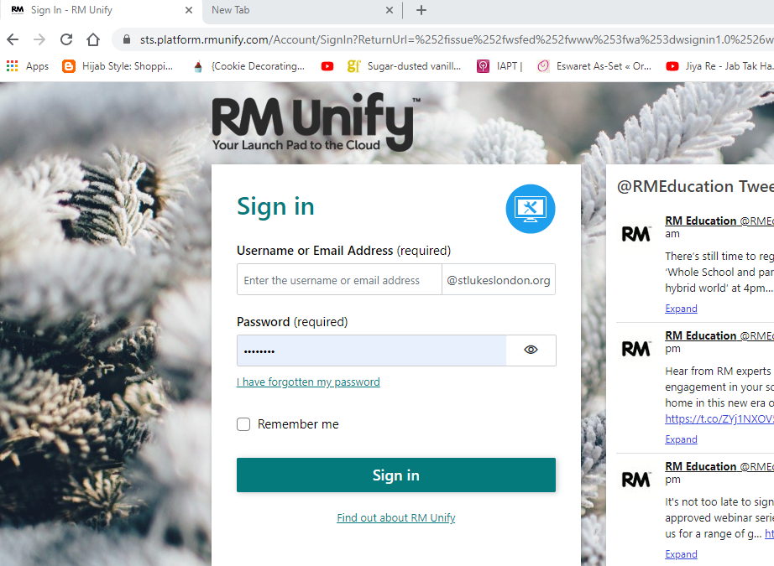

- Ensure you are on the homepage, as circled in pink, in the top left-hand corner
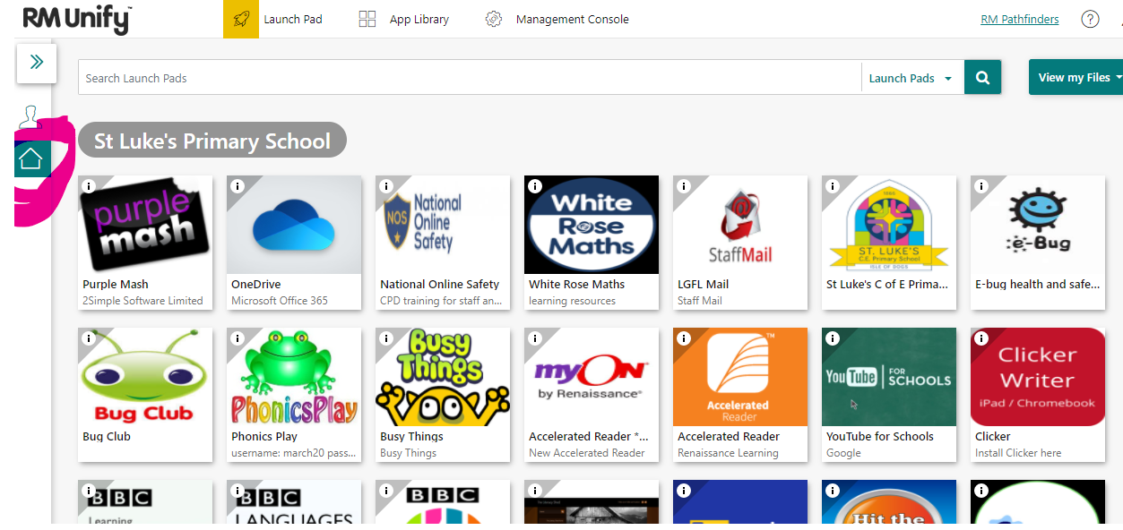

- Click the One drive tile (blue cloud):
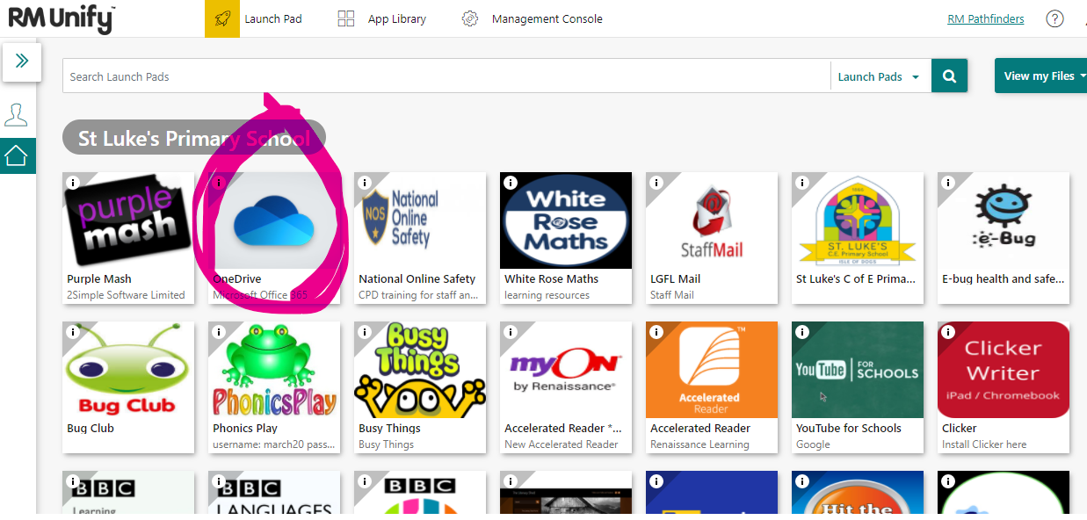

- Click the waffle at the top left-hand corner, (as circled):
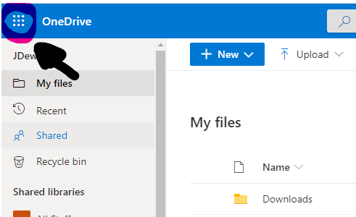

- Select Teams:
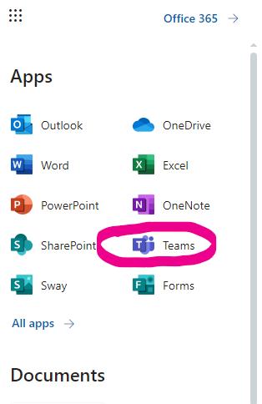

- This will bring you to the Teams homepage, where you can select your child’s class tile:
