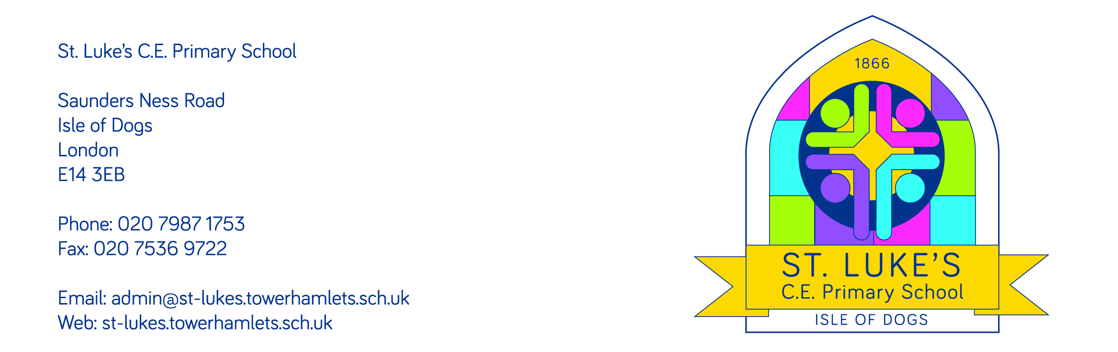
Breakfast Club Registration Form
Child’s Name
Child’s Address
All parents/carers names and addresses
(if different)
Telephone numbers
Medical Needs
Please list below any medical needs or conditions related to your child
Dietary Needs
Please list below any allergies or dietary needs relating to your child
Are you using this facility:

- Because you are a working parent
- Member of Staff
- Child is a recipient of Pupil Premium / EHCP and other (please state) _________________
Please indicate the days you will be using this facility this half term

Monday Thursday

Tuesday Friday

Wednesday

